**GENERAL INFORMATION**

**2024-2025**

Full Name of Youth __________________________________________________________________________

Preferred Name________________________________

Address ___________________________________________________________________________________

__________________________________________________________________________________________

Grade ___________ Age of Youth _____________ Date of Youth’s Birth _______________________

Youth’s Email Address______________________________________________________________________________

Youth’s Cell Phone Number______________________________________ Text? Yes No

Parent/Guardian Name(s) ________________________________________________________________________

Parent/Guardian Phone Number(s) __________________________________________ Text? Yes No

Parent/Guardian Email(s) _________________________________________________________________________

Emergency Contact Name(s) ________________________________________ Relation: ______________________

Emergency Contact Phone Number(s) _______________________________________________________________

**HEALTH INFORMATION**

Do you have medical insurance? Yes No

Name of Policy Holder: _______________________________________________________________________

Relation: ________________________ Policy Holder Phone Number: _________________________________

Insurance Company/ Plan Name __________________________________________________________________________________________

Insurance Company Phone Number: ____________________________________

Insurance Company Policy Number _____________________________________

Group Name ___________________________

Allergies___________________________________________________________________________________________

Dietary Restrictions __________________________________________________________________________________

Medical Conditions we should know about _______________________________________________________________

Does allergy require an EpiPen? ______ Date of last tetanus shot ___________________

Name of Physician ___________________________________________Phone __________________________

Dentist/Orthodontist: ________________________________________Phone __________________________

Medication needed at any youth group events, lock-ins, etc.? Yes No

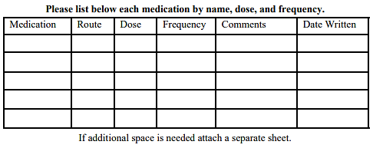Who will dispense meds listed above? (If applicable, circle one) Youth Staff

|  |  |  |  |  |
| --- | --- | --- | --- | --- |
| **Medication** | **Dose** | **Frequency** | **Comments** | **Date Written** |
|  |  |  |  |  |
|  |  |  |  |  |
|  |  |  |  |  |
|  |  |  |  |  |
|  |  |  |  |  |



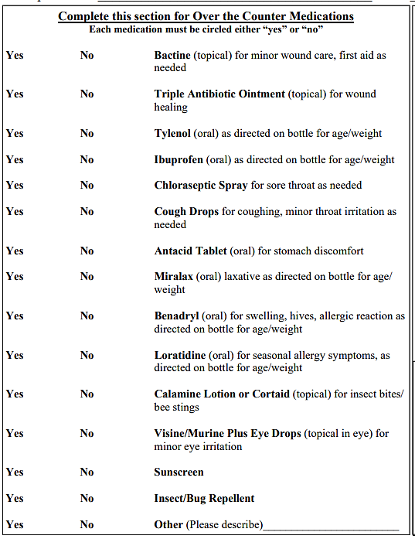

**PERMISSIONS & SIGNATURE (2018-2019 Youth Ministry Year)**

I, _________________________________ the parent/guardian of ___________________________ agree to:

PARTICIPATION

1. Give permission for the youth on this form to participate in all youth group activities of Christ Presbyterian Church. I understand that my child will be involved in programming on the CPC campus, local mission opportunities, and fellowship outings. I have spoken with my child and they agree to show respect to the adult mentors, other youth, themselves, and others property.

PHOTOGRAPHY/VIDEO/SOCIAL MEDIA

2. Give Christ Presbyterian Church permission to use now or in the future, without limitation, or obligation, any and all media, including photographs, film footage, or tape recordings, which may include my child’s image or voice for the purpose of ministry, art, advertising, education, or promotion of the church or youth ministry program, and release Christ Presbyterian Church from any claim or liability to that use. I understand that if I give notice to Christ Presbyterian Church that I object to any particular picture or video being used publicly, that it will be removed as soon as possible.

TRANSPORTATION

3. Give my permission for my child to ride in any vehicle with an adult mentor/chaperone of Christ Presbyterian Church.

SAFETY

4. Give permission, as necessary, for the Associate Pastor and/or adult youth mentors search a youth’s belongings when the health, well-being, or safety of the youth or others requires it.

MEDICAL

5. Hold harmless Christ Presbyterian Church, employees, and volunteers for all claims alleging bodily injury or property damage occurring while the participant is at a CPC youth ministry activity. 6. Give the Associate Pastor and/or adult youth mentors permission to provide over the counter medications following the dosage and directions on medical container, and as indicated on form above. 7. Give the Associate Pastor and/or adult youth mentors permission to provide medications brought to events and lock-ins by parent/guardian or prescribed by a physician while in attendance. 8. Give permission to the Associate Pastor and/or adult youth mentors to transport my child to the local hospital for emergency services, if necessary. I understand that all effort will be made to reach me before any medical procedure is performed, unless it endangers my child’s life, causes disfigurement, physical impairment or undue discomfort should treatment be delayed. If I cannot be reached in an emergency, as the parent and/or legal guardian, I authorize the treatment of my child by the qualified and licensed medical professionals/physicians and give permission to hospitalize, secure proper treatment for, and order injection, anesthesia, or surgery for my child. In addition, the Associate Pastor and/or adult youth mentors have permission to obtain a copy of my child’s health record from providers who treat my child and these providers may talk with the Associate Pastor and/or adult youth mentors about my child’s health status. 9. I understand the information on this form will be shared on a "need to know" basis with the Christ Presbyterian Church staff and Youth Ministry Team. 10. I give permission to photocopy this form.

Signature of Parent/Guardian____________________________________________________ Date__________________

This release is signed of my own free will.

**YOUTH COVENANT**

**Christ Presbyterian Church**

I will be open to the surprising work of God, even when it comes through the unexpected (like food I dislike, exhausting play, and people who are very different from me).

I will be a part of a long-term experiment in Christian community while with this group, showing respect and attentive love to each person.

Whenever I am with this group, I will seek to follow the example of Jesus who did not come to be served, but to serve.

I will seek to avoid actions or attitudes that might detract from the building of Christian community or the mission we have been called to accomplish (complaint, illegal drugs, alcohol, gossip, profanity, tobacco, etc.).

I will honor the adults who have so graciously given their time in order that this group might happen. I will show them the respect they deserve, for I know that they love me and always have my best interests in mind.

I will not destroy any property, but will instead leave things a little better than they were before I got there.

I will honor the group and the importance of the time we have together by living within the basic behavioral guidelines for the group.

During youth group outings I will not wander off from the group, and will stay with at least two friends, being careful to pay attention to when I need to check in with an adult.

I will participate in the activities that have been planned for me, whether they be games, small group activities and lessons, or eating at meal time.

I also understand that I am to be respectful of our worship times and of our small group space, and I will do my best to be attentive during this programming.

In the unlikely event I choose to disregard this Covenant, I understand that my parents may be called and I may be asked to leave the group until such time that I choose to regard the covenant.

This Covenant is committed to by:

_____________________________________________________________________________________

Youth Participant Grade Date

_____________________________________________________________________________________

Parent/Guardian Date

**CHRIST PRESBYTERIAN CHURCH**

**NOTICE OF CHILD PROTECTION POLICY**

I, the undersigned do hereby acknowledge that I have received the Christ Presbyterian Church Child Protection Policy. I covenant to work with the CPC staff and volunteers to help create a safe environment for my child, and all of the other children who participate in worship and programming at Christ Presbyterian Church of Toledo, OH.

_____________________________________________________________________________

Signature of Parent/Guardian Date of Signature

